RoyalCert is now GSTC-Accredited
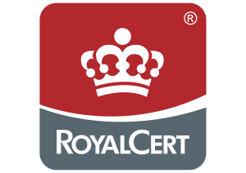
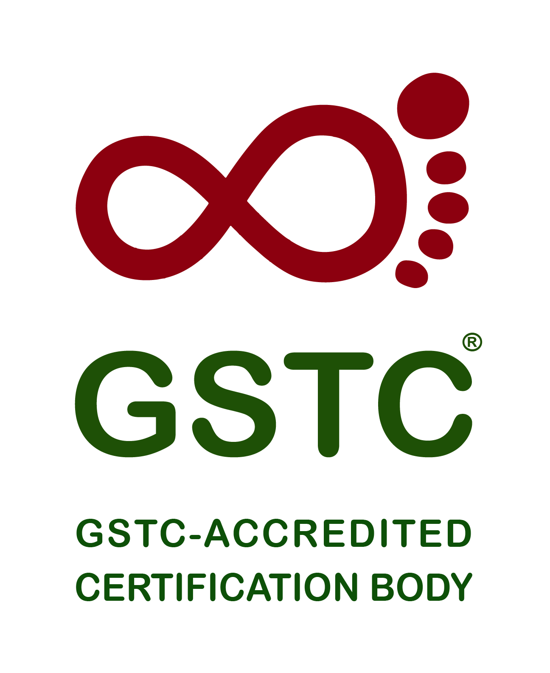
The Global Sustainable Tourism Council (GSTC) is pleased to announce that RoyalCert has gained the GSTC-Accredited Certification Body status.
RoyalCert is an International certification body with HeadQuarters in Germany and operating in +40 countries globally. RoyalCert offers inspection, training, assessment and certification services to a wide range of industries, including the Tourism Industry, and serving thousands of customers worldwide. With experienced auditors, RoyalCert is committed to sustainable growth, focusing on integrity and customer satisfaction.
The stated scope of the GSTC Accreditation of RoyalCert is for certifying hotels and tour operators in Türkiye, Germany, Italy, Greece, United Arab Emirates, Thailand, and the Netherlands.
Achieving the GSTC-Accredited status means that a Certification Body has been verified to be conducting proper certification of businesses, such as hotels or tour operators, in a competent and neutral manner, following processes and procedures detailed in the GSTC Accreditation Manual.
Businesses certified by a GSTC-Accredited Certification Body, meeting all the GSTC Criteria (or a GSTC-Recognized Standard), have the highest level of assurance* and credibility available. With an accredited certification, customers and buyers are assured that the business was certified in a credibly verified procedure in a transparent, impartial, and competent manner.
Attesting to that, those businesses certified by a GSTC-Accredited Certification Body can display a unique GSTC logo with a traceable code. The purpose of the GSTC Accreditation is to provide a higher level of assurance and reward genuine practitioners of sustainable tourism, which builds confidence and credibility with consumers.
The Accreditation process is a months-long procedure, as GSTC looks very hard at the Certification Body’s operation and its process of certification to assure that they issue certifications based on merit and neutrality.
“We are glad that our Türkiye office is the first locally accredited Certification Body in the country to achieve GSTC Accreditation. Even though RoyalCert holds multiple accreditations for management system certification & inspections services, preparing ourselves to meet GSTC requirements took dedication and time. We are glad to have taken this step and look forward to contributing to the tourism industry's journey to a more sustainable future” says Christos Markopoulos RoyalCert General Manager.
The GSTC Accreditation Manual for Certification of Hotel/Accommodation & Tour Operator provides detailed technical requirements for certification of Hotel/Accommodation and Tour Operator. Certification Bodies are required to comply with ISO 17065 Conformity Assessment (Requirements for bodies certifying products, processes and services) and GSTC specific requirements. Among these requirements are impartial and competent certification procedures, auditor experience and qualifications, certification decision making, rigorous surveillance of certified businesses, and proper promotion of their services.
“Accreditation is an intense and intrusive review of a Certification Body’s management, entire auditing process, and certification-decision-making process,” says GSTC CEO, Randy Durband. “Gaining this mark of compliance to the GSTC Accreditation Manual is rigorous and is designed specifically for tourism and hospitality, without a peer. We applaud RoyalCert for opening themselves up to this level of external review, for which their client businesses are entitled to market favor.”
Hotels that follow sustainability standards that wish to stand out with reputable certification as a sustainable hotel, should seek sustainable hotel certification by a GSTC-Accredited Certification Body.
Tour Operators that want to demonstrate through their adherence to sustainability standards are encouraged to seek sustainable tour operator certification by a GSTC-Accredited Certification Body.
Destinations that are managed in accordance with sustainability standards can aim for destination certification by one of the GSTC-Accredited Certification Body

About the Global Sustainable Tourism Council (GSTC)
The Global Sustainable Tourism Council® (GSTC®) establishes and manages global sustainable standards, known as the GSTC Criteria. There are two sets: Destination Criteria for public policy-makers and destination managers, and Industry Criteria for hotels and tour operators.
The GSTC Criteria form the foundation for Accreditation of Certification Bodies that certify hotels/accommodations, tour operators, and destinations as having sustainable policies and practices in place. GSTC does not directly certify any products or services; but it accredits those that do. The GSTC is an independent and neutral USA-registered 501(c)3 non-profit organization that represents a diverse and global membership, including national and provincial governments, leading travel companies, hotels, tour operators, NGO’s, individuals and communities – all striving to achieve best practices in sustainable tourism.
Information for media and the press: https://www.gstcouncil.org/about/for-the-press/

About RoyalCert® International Registrars
At RoyalCert®, they take pride in being a leading international registrar that has been instilling confidence through their exceptional certification, training, inspection, and testing services since 1996. With a global presence in over 40 countries and a growing reach, its mission is to ensure sustainable growth for both its esteemed customers and themselves.
Its Vision: A Global Footprint for Sustainable Growth
Driven by their unwavering vision, they strive to create a lasting global footprint. They are committed to making a positive impact on the industries they serve, helping businesses achieve excellence and building trust in their products and services. Its ultimate goal is to contribute to a more sustainable and prosperous future for all.
Global Reach, Local Expertise: An International Team
With a vast network of +1,700 skilled professionals spread across five continents, their team is the backbone of its success. Their expertise and dedication ensure that RoyalCert's services uphold the highest quality standards, making a positive impact on businesses worldwide.
—-
* Note: General assurance levels:
3rd-party certification by an Accredited Certification Body (impartiality is certain)
3rd-party verification (impartiality is not certain)
2nd-party verification (not impartial)
1st-party self-assessment
No verification at all

